MINI PROJECT

Title : Azure Blob Storage to Blob Storage Data Pipeline using Azure Data Factory
Objective : To build a complete end-to-end Azure Data Factory pipeline that reads a CSV file from Azure Blob Storage, validates it using the Get Metadata activity, and copies it to another Blob Storage container successfully.
Problem Statement : Design and implement a cloud-based data pipeline that reads a CSV file from Azure Blob Storage, validates its metadata, and copies it to a destination Blob Storage container using Azure Data Factory.
Azure Services Used
- Microsoft Azure Portal
- Azure Resource Group
- Azure Storage Account
- Azure Blob Storage
- Azure Data Factory
- Linked Service
- Datasets
- Get Metadata Activity
- Copy Data Activity
- Azure Monitor
- Azure IAM
Pipeline Workflow
- Uploaded the Customer_Orders.csv file to the source-data Blob Storage container.
- Created source and destination datasets in Azure Data Factory.
- Configured a Linked Service to connect Azure Data Factory with Azure Blob Storage.
- Added the Get Metadata activity to validate the source file.
- Added the Copy Data activity to copy the file to the destination-data container.
- Executed the pipeline using Debug and Trigger Now.
- Verified successful execution in the Monitor section.
- Confirmed that Customer_Orders_Copy.csv was created in the destination container.

Step 01 Customer Orders Dataset Uploaded to Source Blob Container
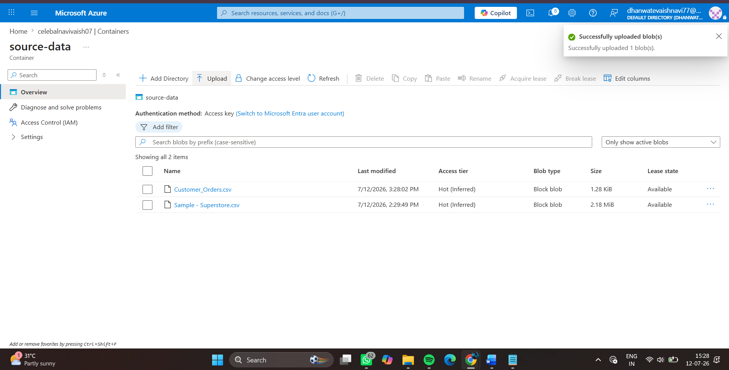

Step 2: Create the Source Dataset
Created the DS_Source_CustomerOrders dataset in Azure Data Factory by connecting it to the Customer_Orders.csv file stored in the source-data Blob Storage container. The dataset schema was imported successfully, enabling Azure Data Factory to read the source data.
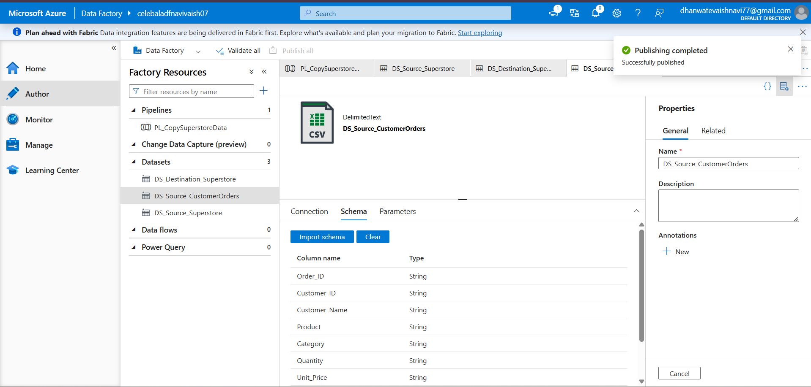

Step 3: Create the Destination Dataset
Created the DS_Destination_CustomerOrders dataset to specify the destination Blob Storage location. The dataset is configured to create the Customer_Orders_Copy.csv file in the destination-data container during pipeline execution.
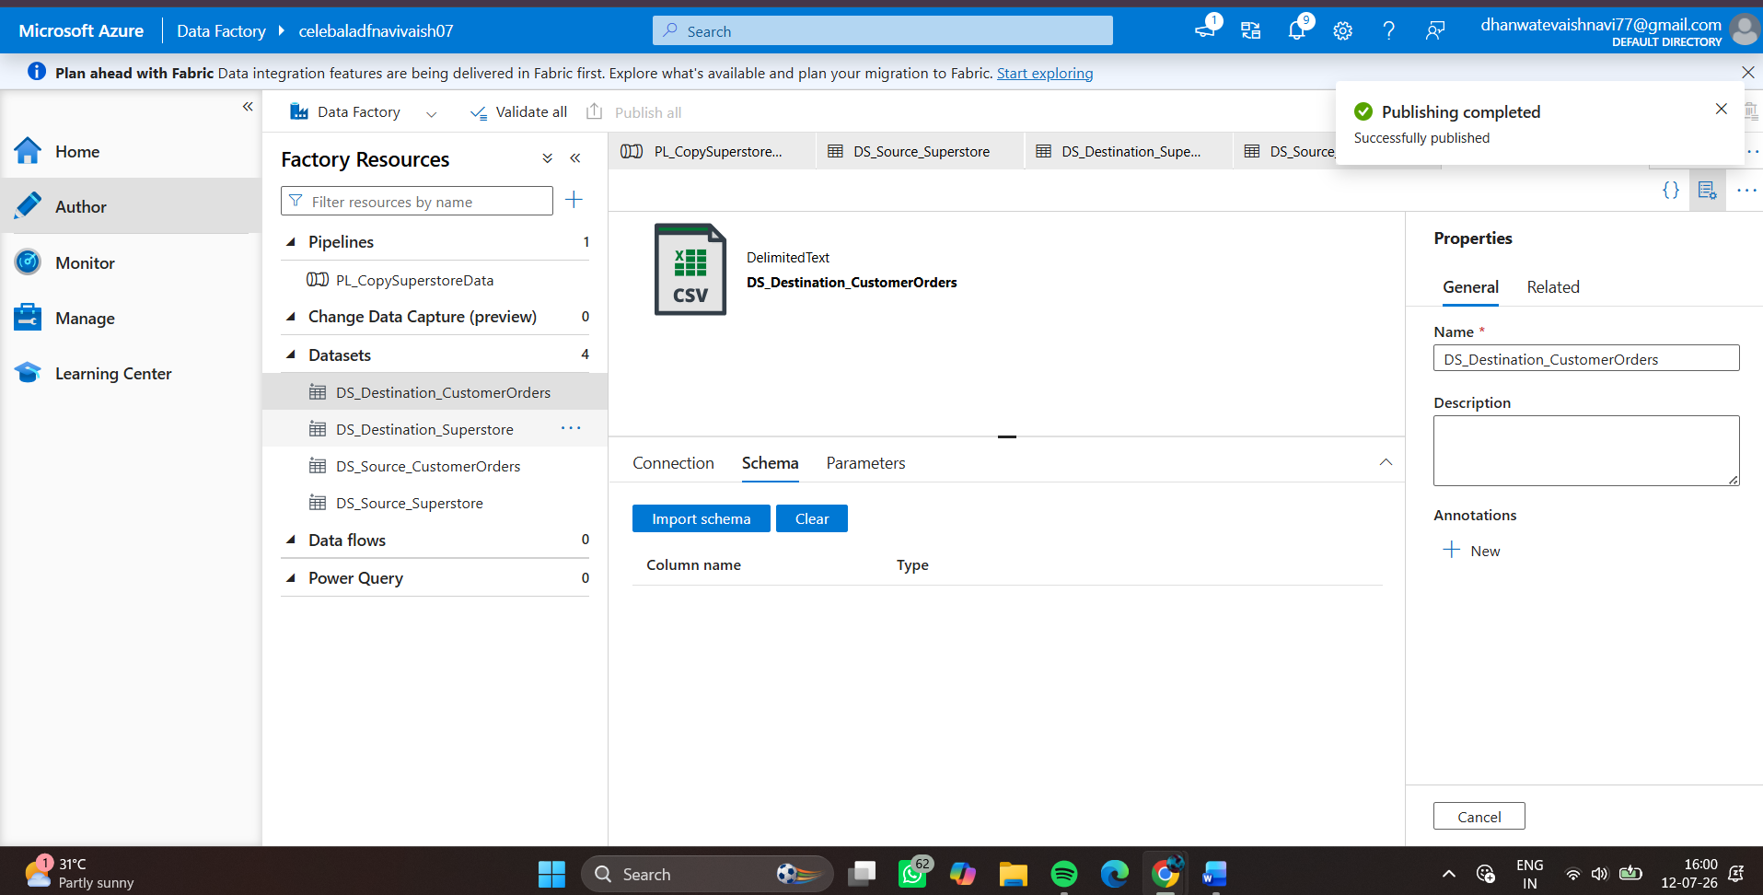

Step 4: Create the Data Pipeline
Get Metadata Activity Configuration : Configured the Get Metadata activity to validate the existence of the source file and retrieve metadata such as file size and last modified timestamp before executing the copy operation.
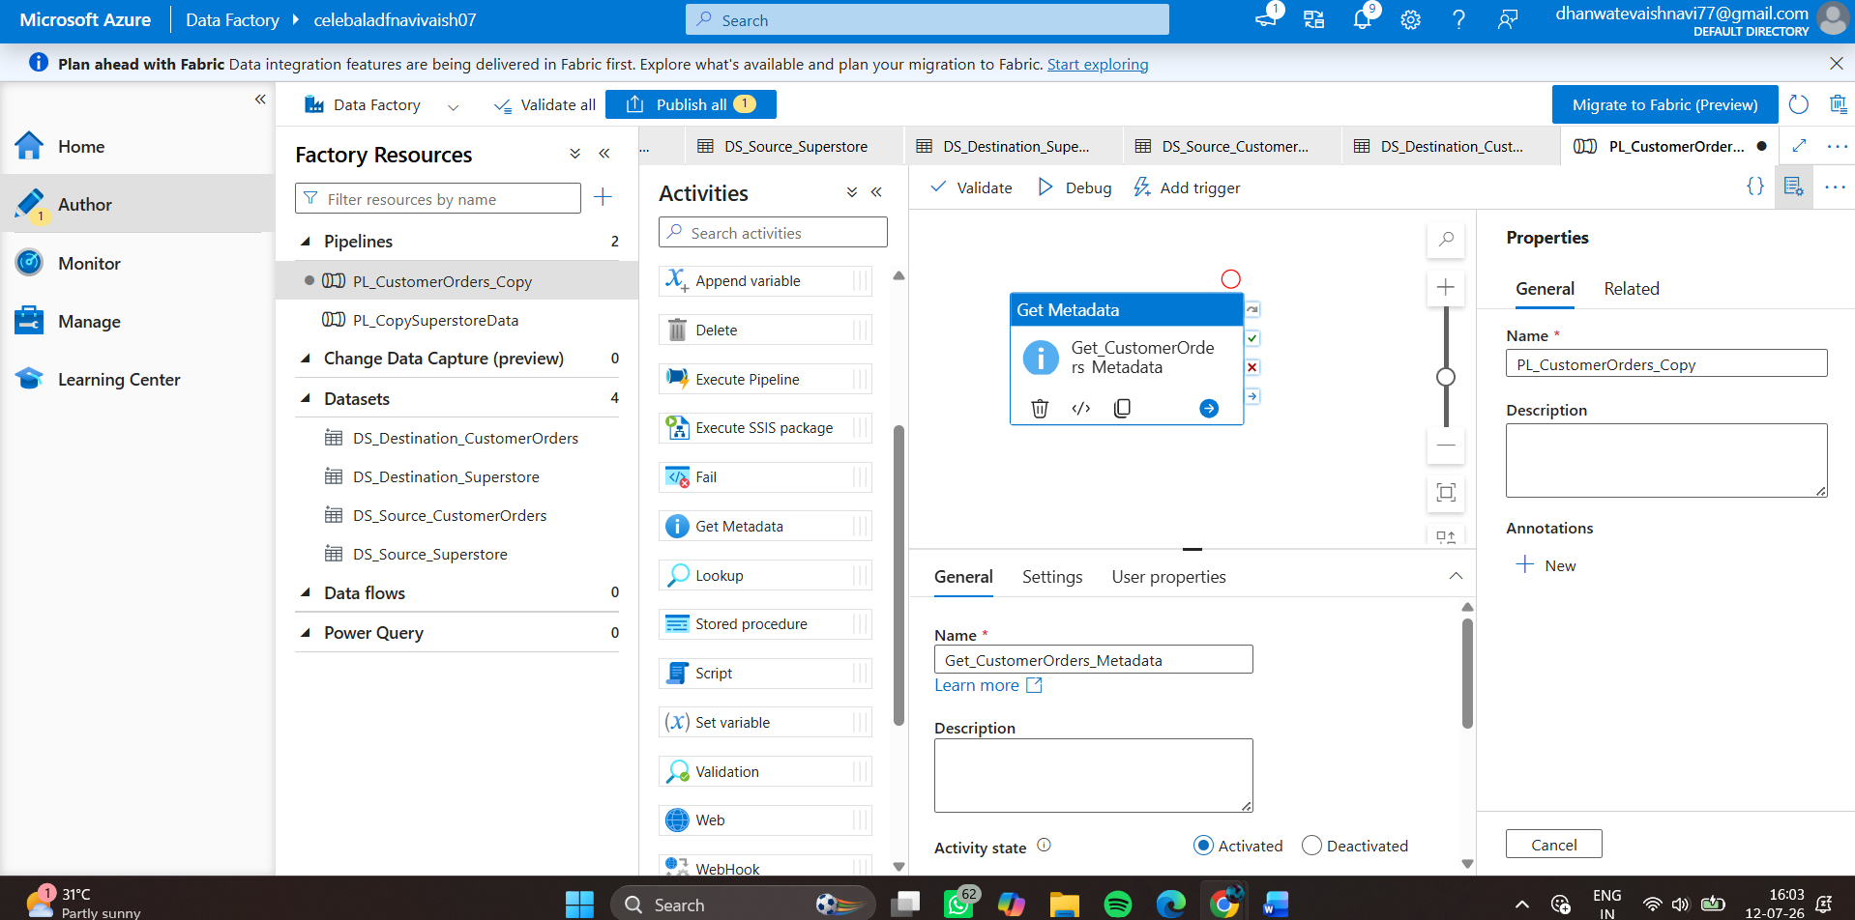

Azure Data Factory Pipeline Design : Developed an end-to-end Azure Data Factory pipeline consisting of a Get Metadata activity followed by a Copy Data activity. The pipeline validates the source CSV file before copying it to the destination Blob Storage container.
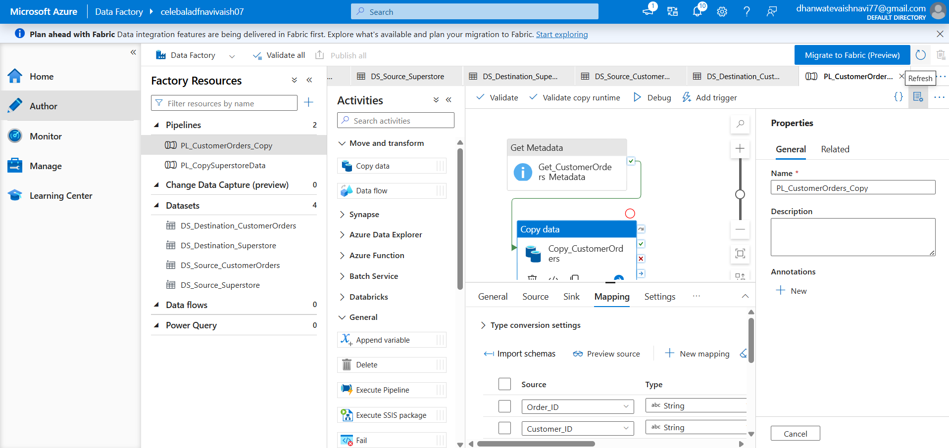

Step 5: Execute the Pipeline
Successful Pipeline Execution : Executed the Azure Data Factory pipeline using the Debug option. Both the Get Metadata and Copy Data activities completed successfully, validating the source file and copying it to the destination Blob Storage container.
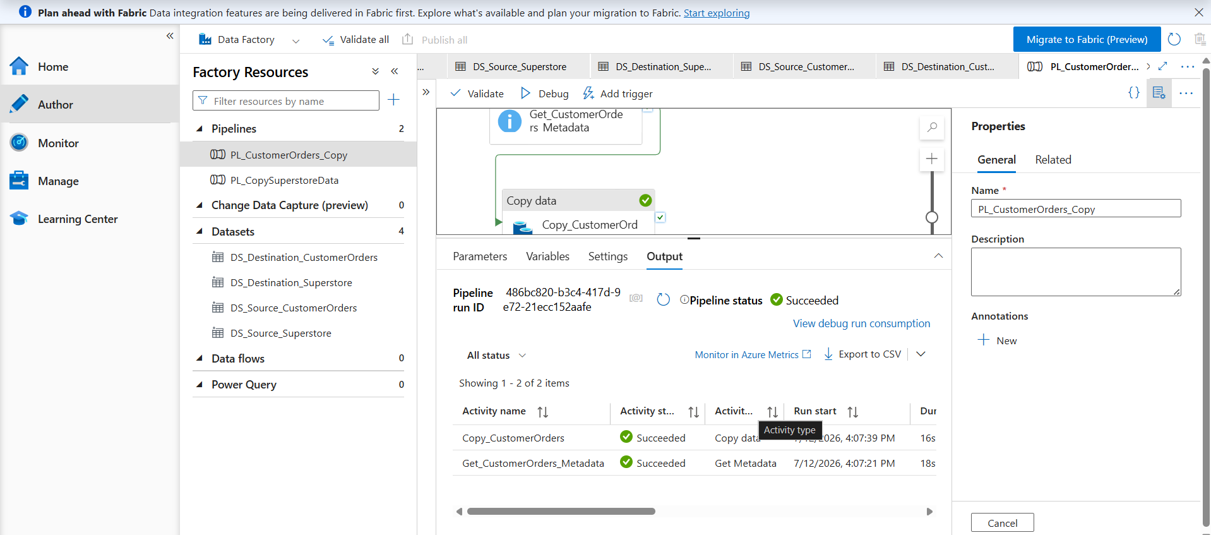

Pipeline Monitoring : The Monitor section displays the successful execution of the Azure Data Factory pipeline, confirming that both the metadata validation and data copy operations completed successfully.
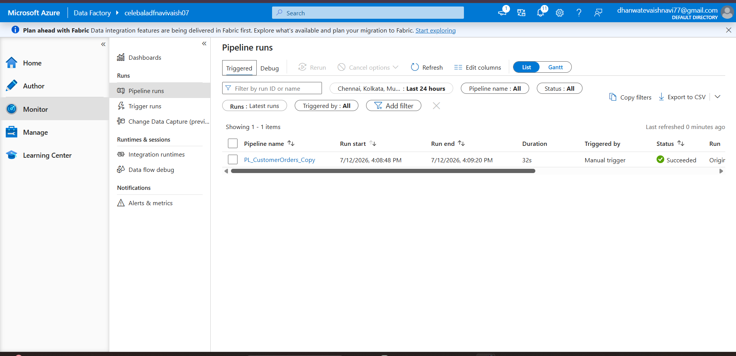

Destination Blob Storage : Verified that the Customer_Orders_Copy.csv file was successfully created in the destination-data Blob Storage container after the pipeline execution.
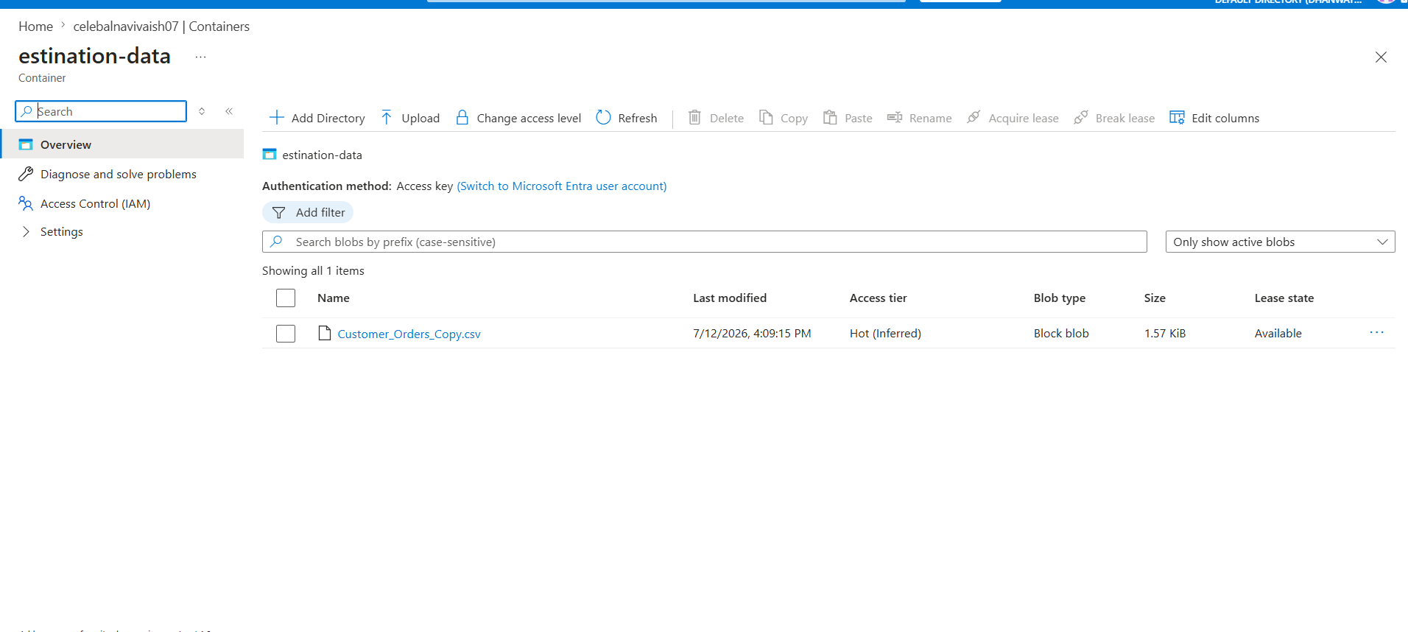

Metadata Validation Output : The Get Metadata activity successfully validated the source CSV file by retrieving metadata including file existence, file size, and last modified timestamp.
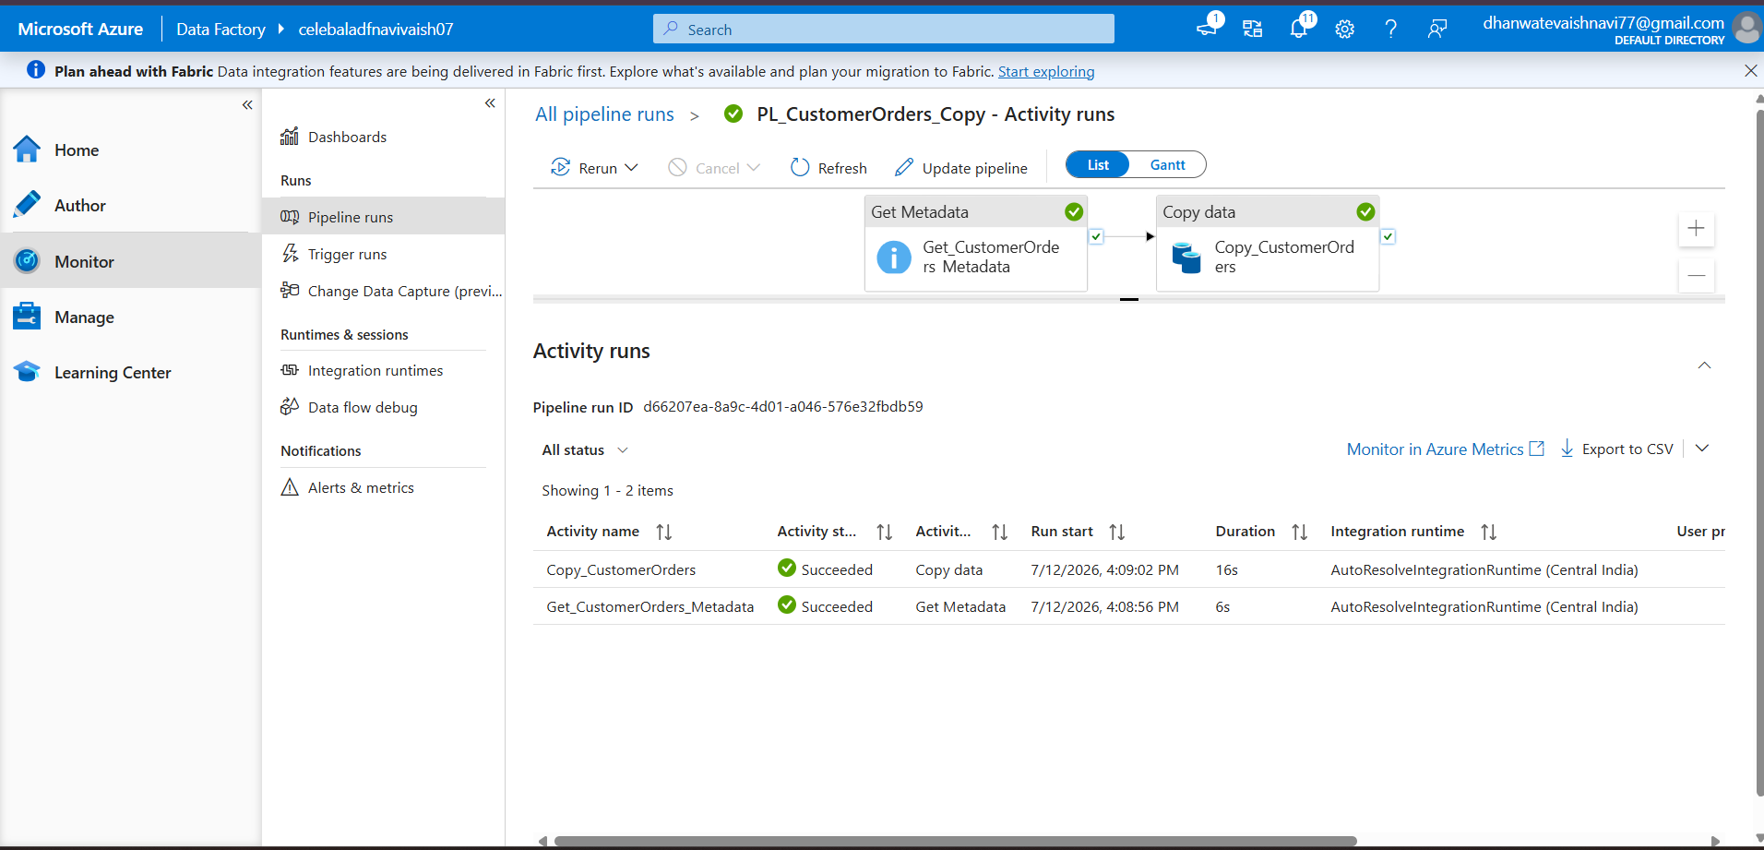
Results
- Successfully connected Azure Data Factory to Azure Blob Storage.
- Successfully validated the source CSV file using the Get Metadata activity.
- Successfully copied the data from the source Blob container to the destination Blob container.
- Verified successful pipeline execution through the Monitor section.
- Confirmed the creation of the output file in the destination container.
Conclusion
The mini project successfully demonstrated the implementation of an end-to-end Azure data pipeline using Azure Blob Storage and Azure Data Factory. The pipeline validated the source dataset, transferred data to the destination container, and monitored execution through Azure Data Factory. This project provided practical experience with Azure cloud services, data integration, pipeline development, and monitoring.

